AWS Assessment Project 7

Project: DevOps-Jenkins-Installation and Configuration on Linux

**TASK 1: Create a Linux Instance**

* Select Amazon Linux 2 AMI & Create Instance

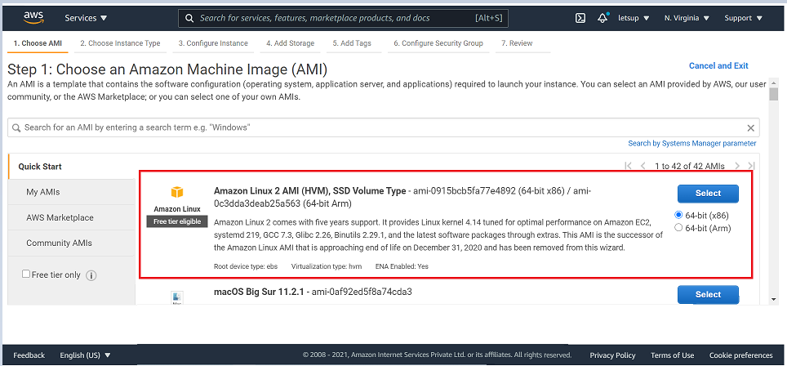

* Instance Details:

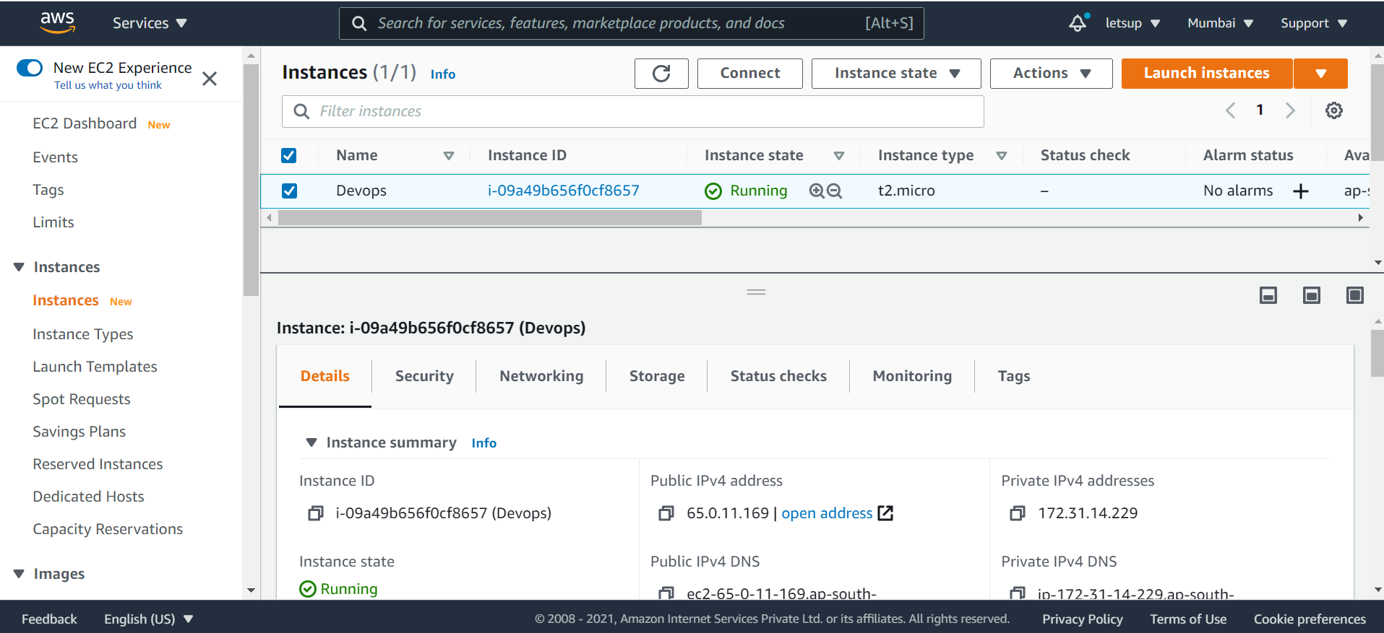

**TASK 2: Install Java**

Now connect to instance created:

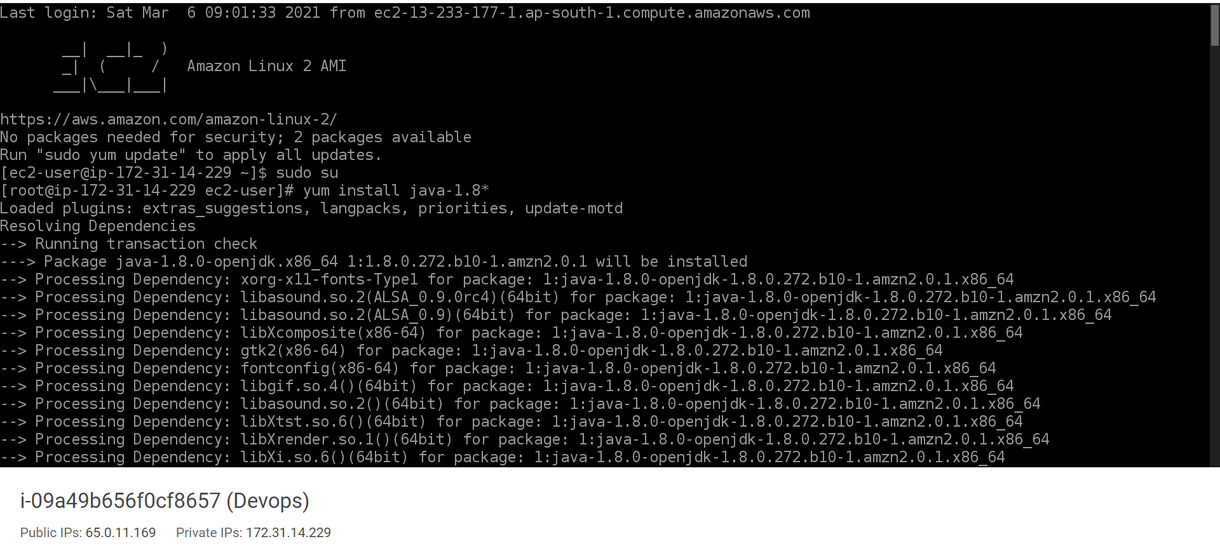

• sudo su – Become Super user

• yum install java-1.8* – Will install Java

**TASK 3: Install Jenkins**

Go to the below link to access the Jenkins repository and install it:

<https://pkg.jenkins.io/redhat-stable/>

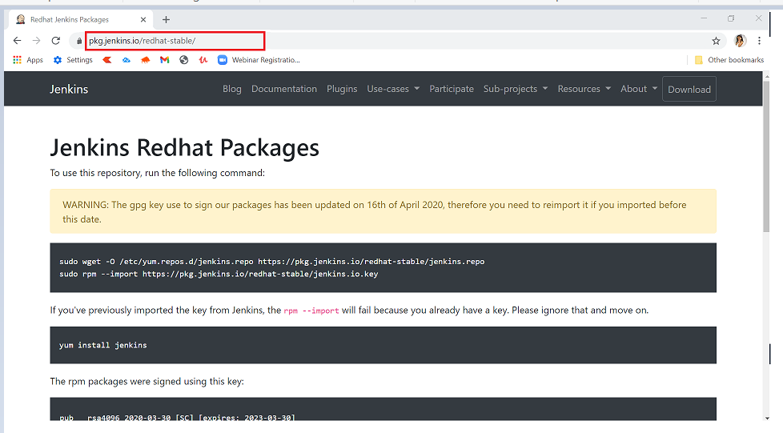

* Get Jenkins repository :
* wget -O /etc/yum.repos.d/jenkins.repo <https://pkg.jenkins.io/redhat-stable/jenkins.repo>

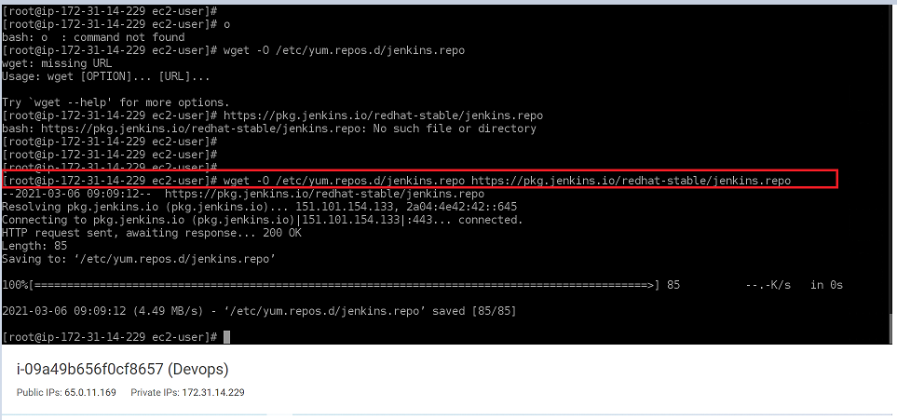

Import the Jenkins key : o rpm --import <https://pkg.jenkins.io/redhat-stable/jenkins.io.key>

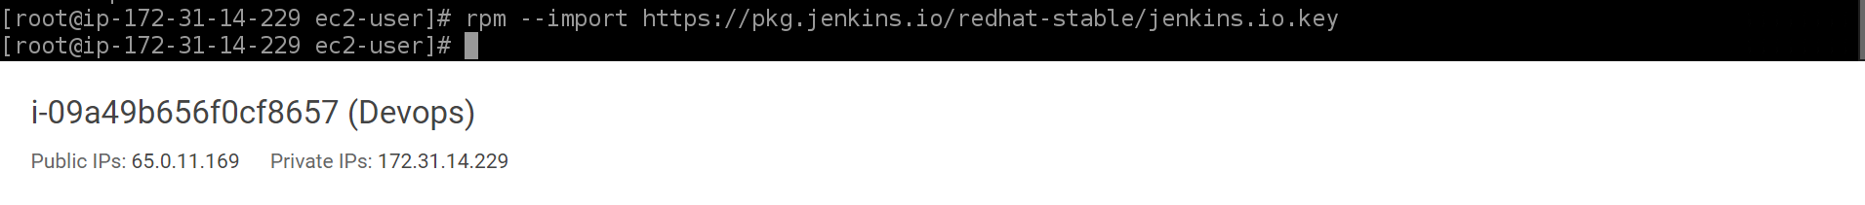

* Install Jenkins :

o yum install jenkins

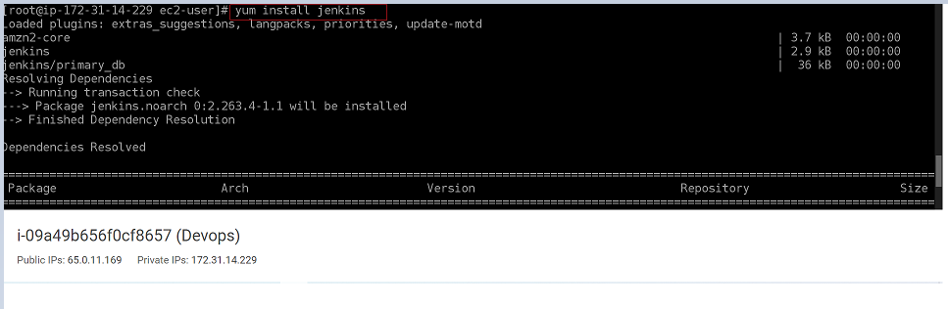

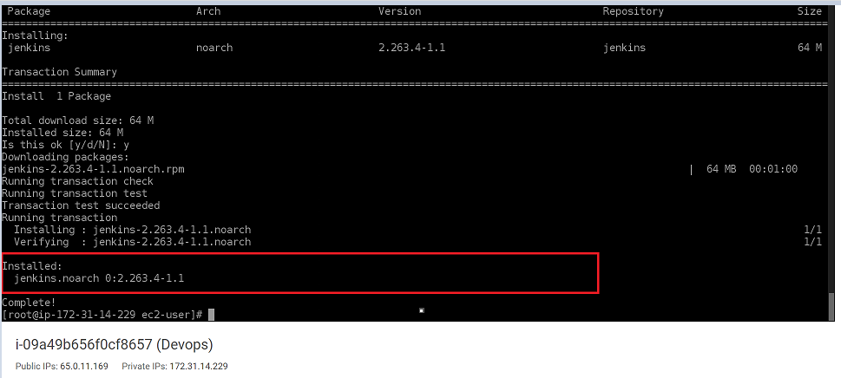

* After installing the Jenkins, check Jenkins status

o service jenkins status

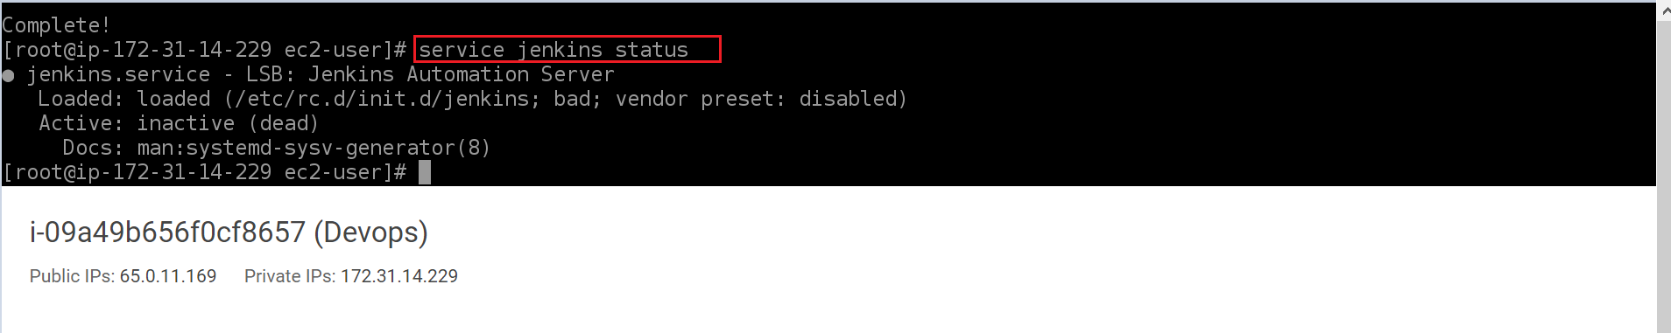

* Start the Jenkins service:

o service jenkins start

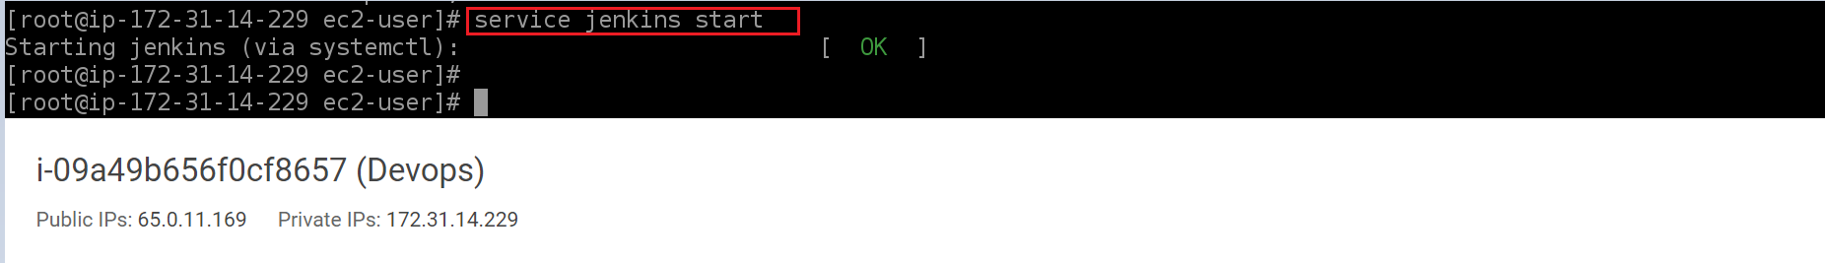

* To continue jenkins installation, go to the browser and access the instance using the public ip along with the port number (i.e., 65.0.11.169:8080)

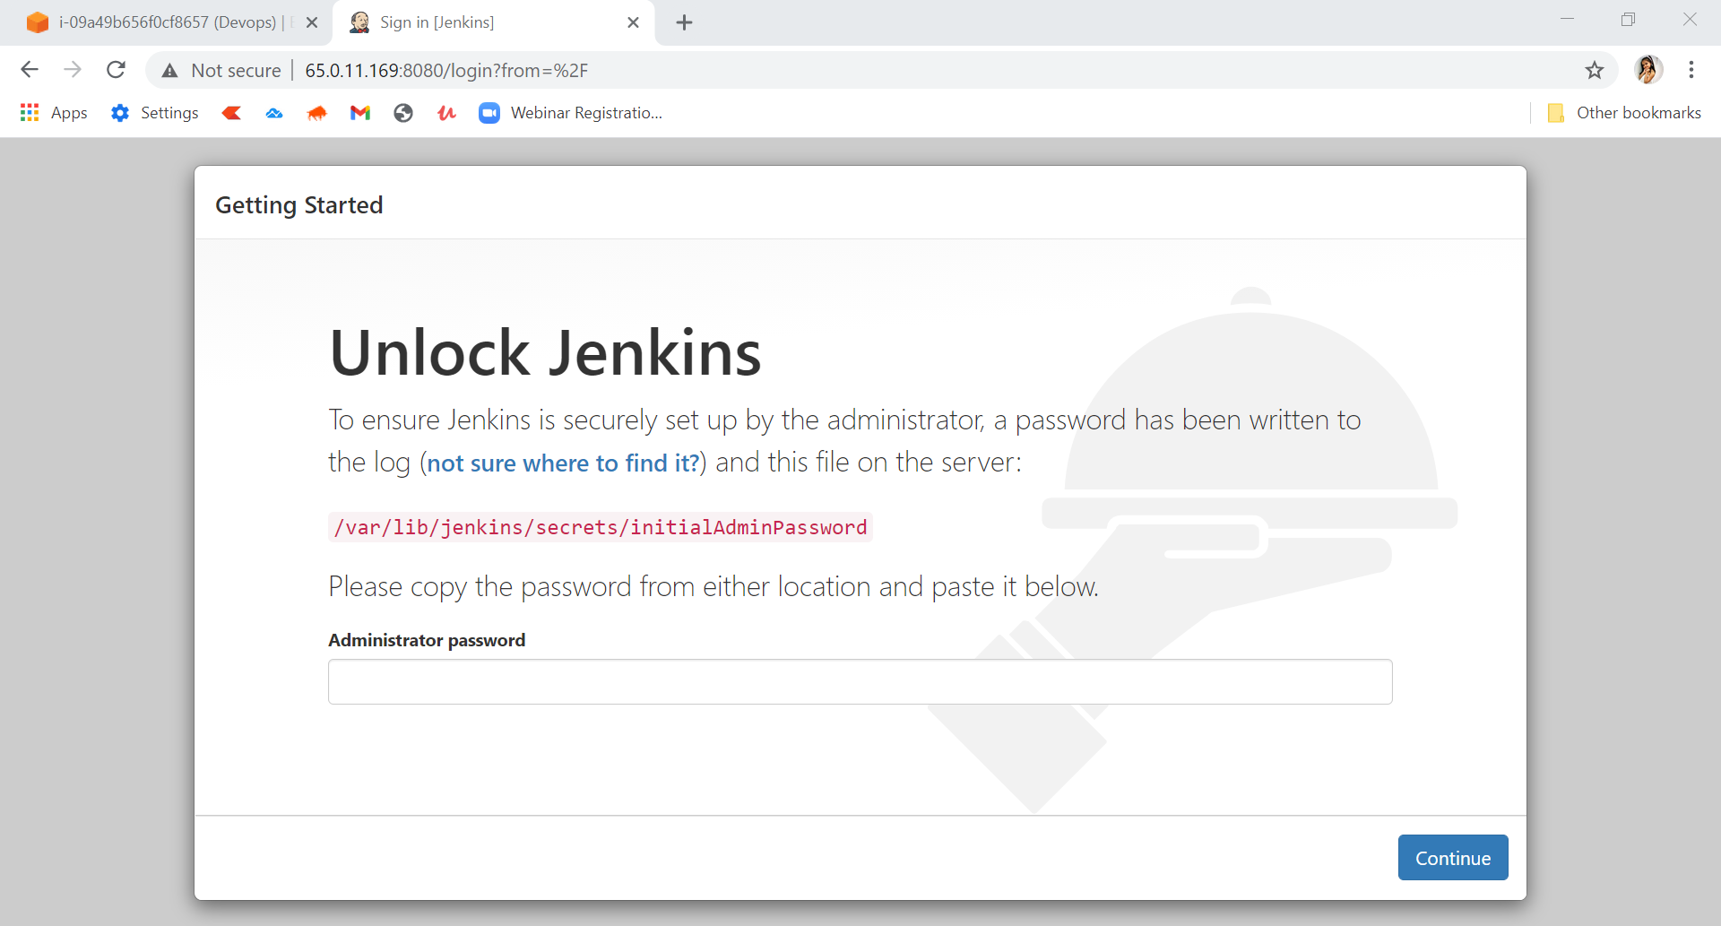

You can see the Unlock Jenkins page asking for Administrator password.

• Copy the path/location of password file mentioned, which we will use to get the administrator password Go back to the instance you connected.

• Path / Location:

o /var/lib/jenkins/secrets/initialAdminPassword

* Open the file with the copied path: o cat /var/lib/jenkins/secrets/initialAdminPassword

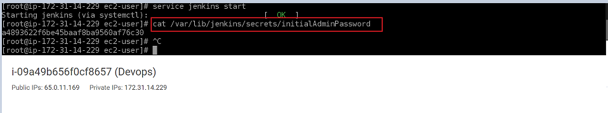

* Copy the password and go to back to the Unlock Jenkins page and paste it

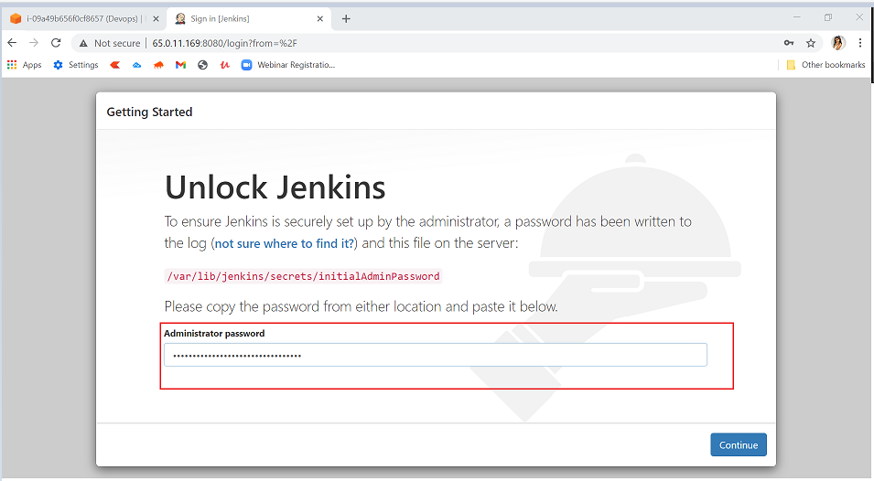

* Click on Continue

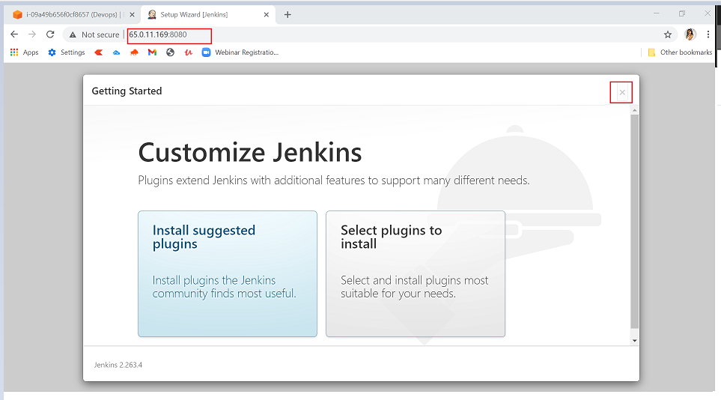

* On the Customize Jenkins page skip the plugins installation & close it

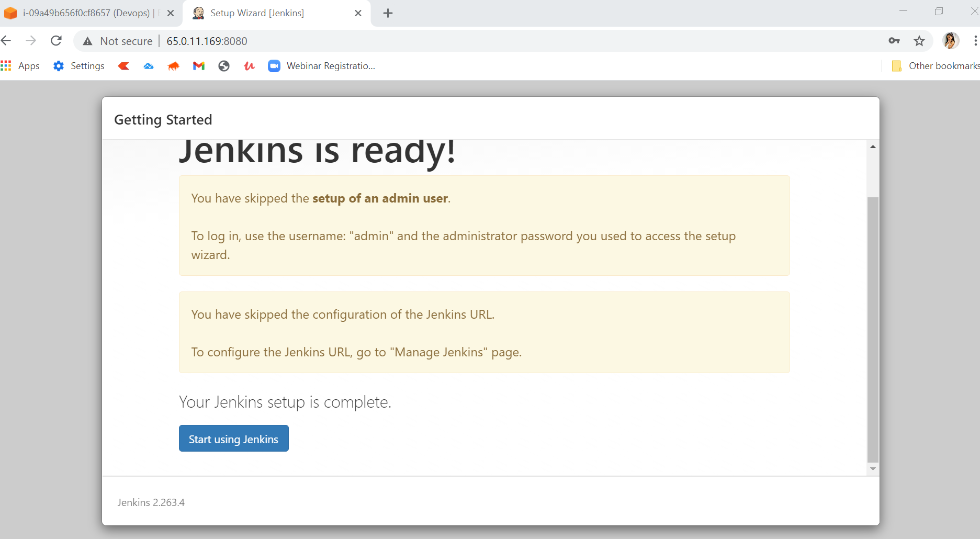

* You can see Jenkins Dashboard showing Welcome to Jenkins!

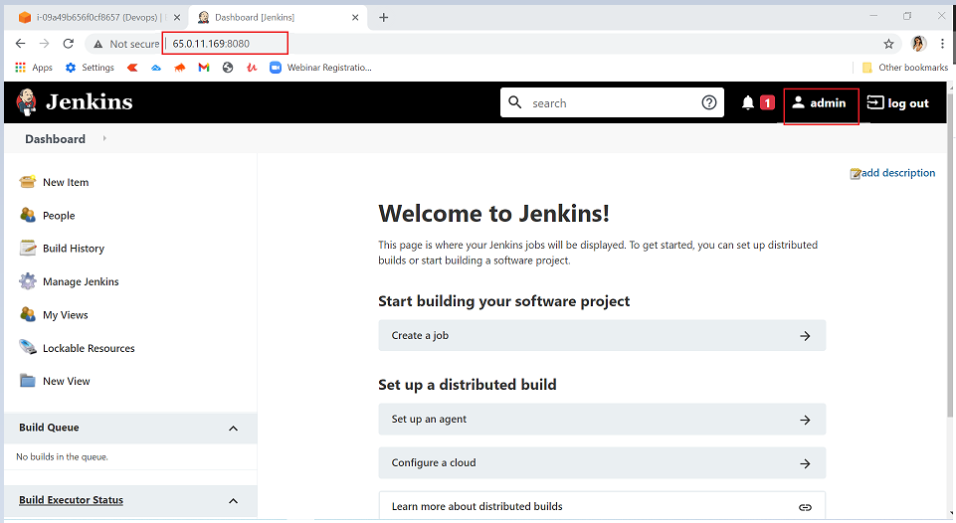

**TASK 4: Configure Admin Password**

Now we will change the machine generated Admin Password and set our own password

• Click on admin as shown in the above image

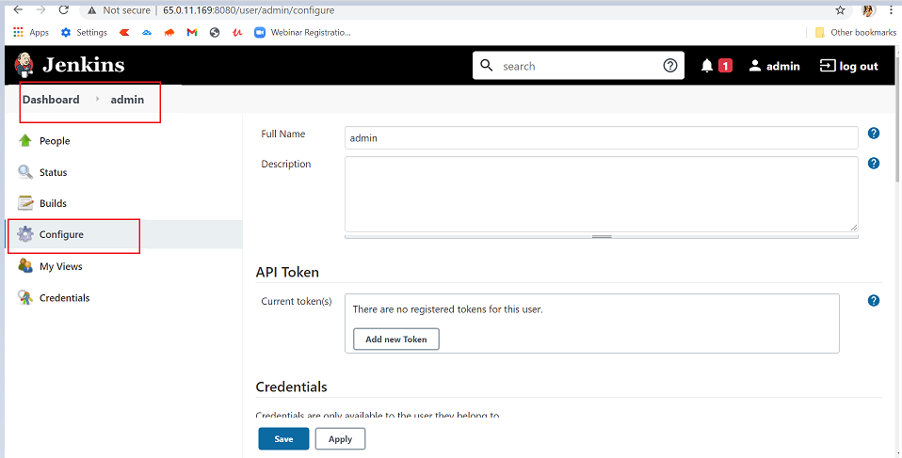

* In Dashboard -> admin click on Configure
* In the password section below type in the new password. Click on Save and then Apply.

You have successfully updated the new password.

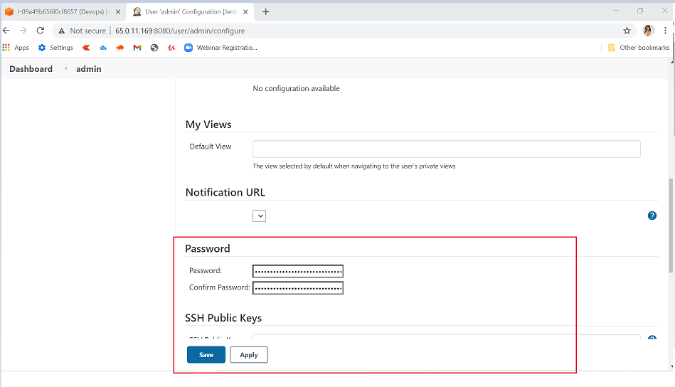

**TASK 5: Create a new Job & Build the job Create a new Job**

• In the Jenkins Dashboard click on **New Item** and then click on **Create a job**

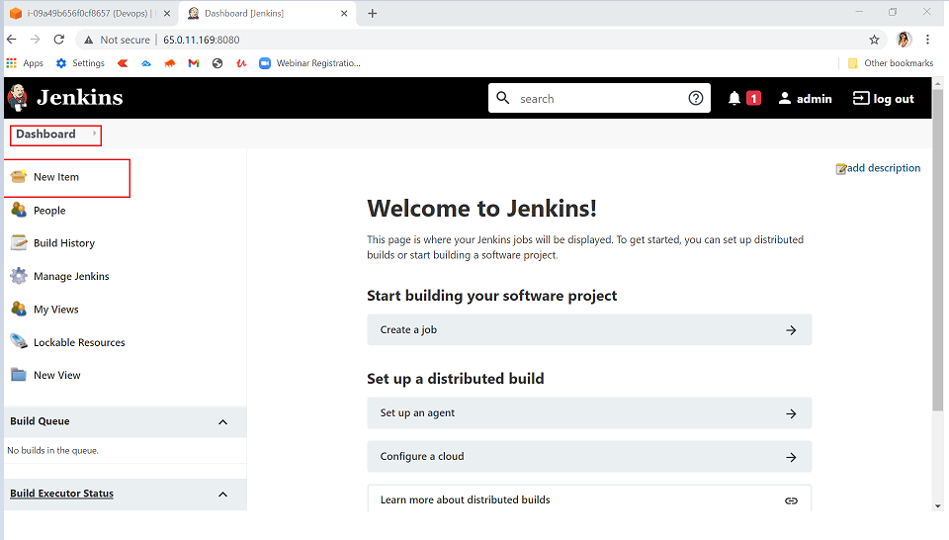

* Enter an item name: Project-Hello1
* Select Freestyle project and click on OK

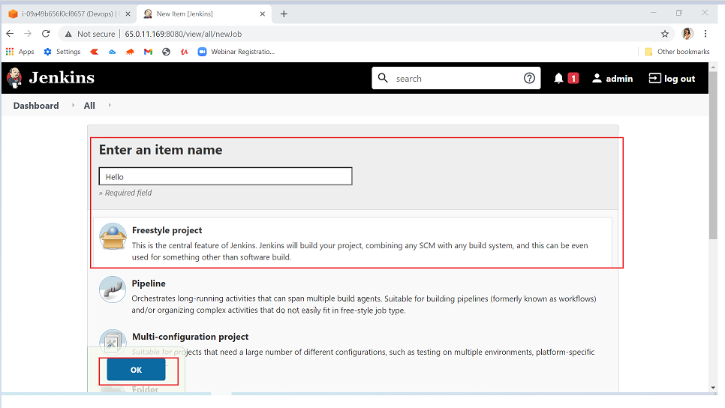

* Build Triggers settings
* In Dashboard -> Project-Hello1
* Click on Build Triggers tab then click on Add build step
* Select Execute shell

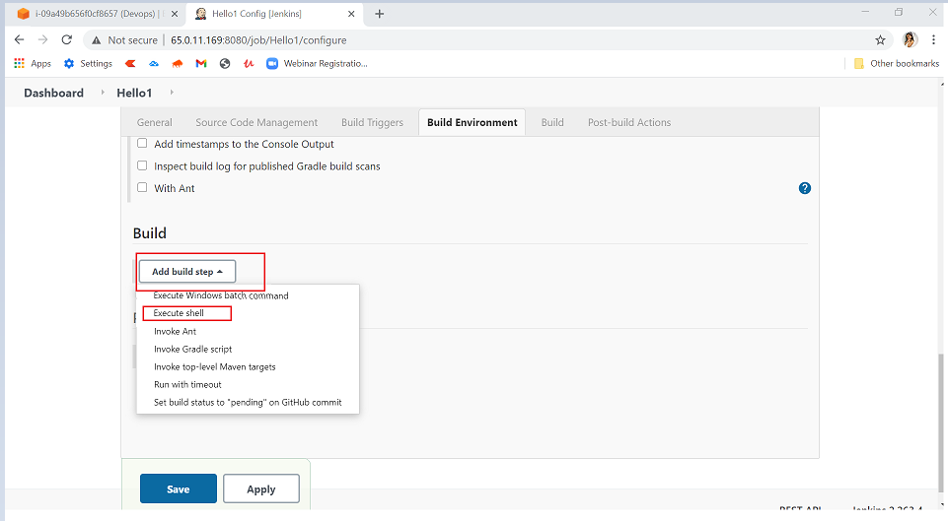

* Build settings
* Under Execute shell in Command field enter following command:

o echo “Hello, Welcome to LetsUpgrade”

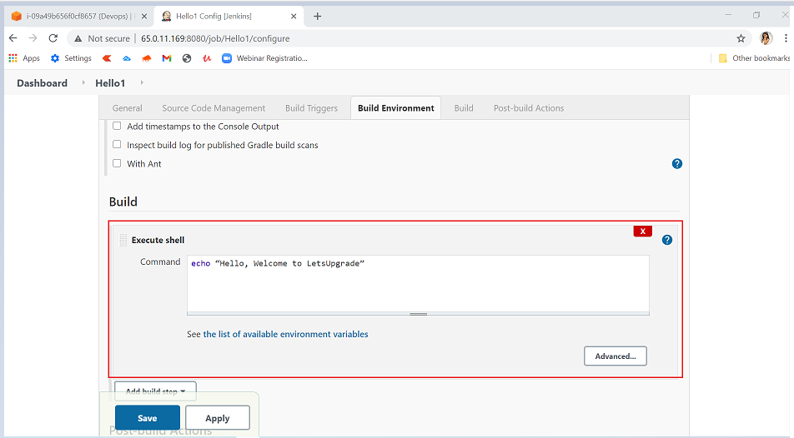

* Click on Save and then Apply

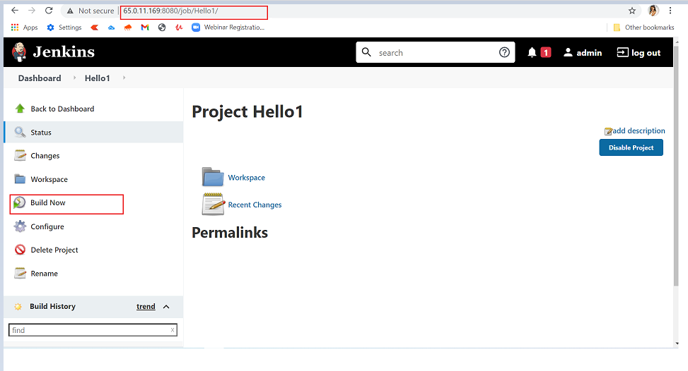

**Build the Job**

* On the Dashboard - Project-Hello click on Build Now

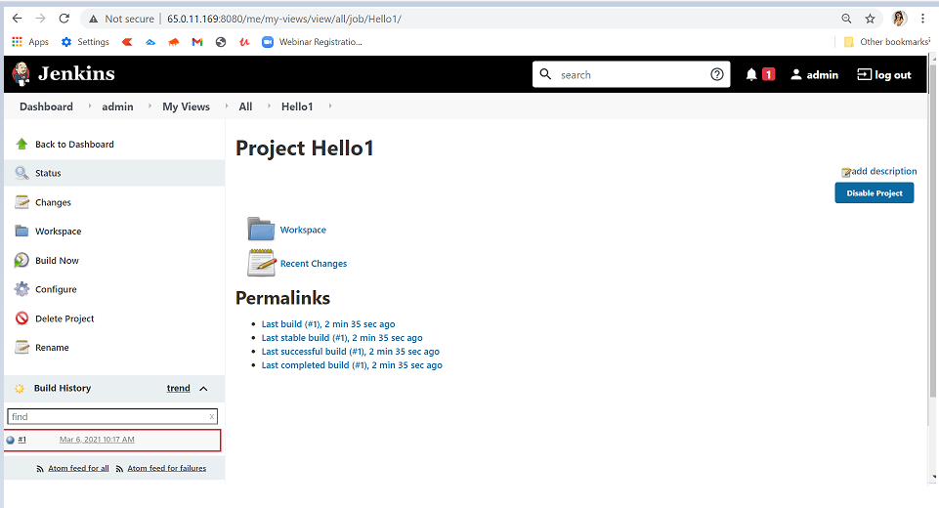

* Once the build is complete, click on the Build number (e.g., #1) under **Build History** Section
* Click on **Console Output**

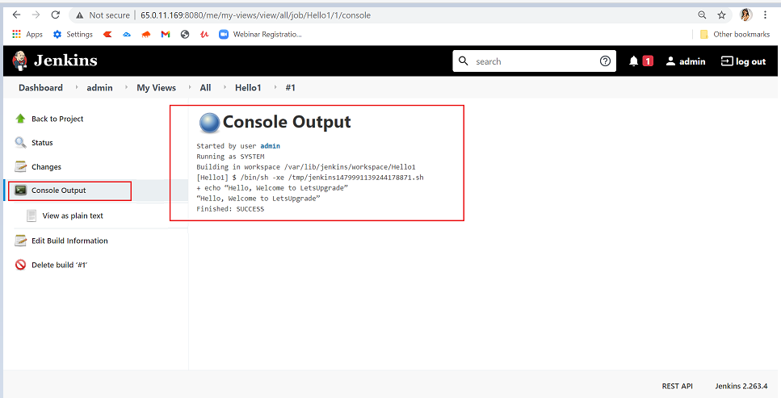

You can see the output of the job with SUCCESS status